Joins:
iteration:
- simple / page oriented nested loops join
- Blocks nested loops join
indexing:
- index nested loops join
Partitioning:
- Sort merge join
- Hash join
Simple nested loops join:
D outer relation
D – M pages
C – N pages
Cost : M + pD * M * N
Page oriented nested loops join:
Cost: M + M * N

Block nested loops join:
No of Blocks = ceil(M/(Buffer pages – 2))
Cost: M + no.ofBlock * N
cost : scan outer + num. blocks in outer relation * scan inner relation
Num of blocks in outer relation: CEIL( number of pages in outer relation/ size of block);

Index nested loops join:
Cost = M + ( ( M* pD) * cost of location matching C record) )
cost of location matching C record = 1+ unu din indexi de jos
Current record in D
if hash index : 1.2 I/Os
if b+ tree index : 2-4 I/Os
clustered index : +1 I/Os for each outer rec in D
unclustered index : up to 1 I/O for each matching record in C
i. Sort-merge join
1. Sort each relation (ex. with external merge sort)
2. Merge, with cost = M + N if the inner partition is scanned only once; M * N worst case
3. Cost = sorting costs + merge cost
Hash join:
Cost = 3*(M+N)

Simple 2-way merge sort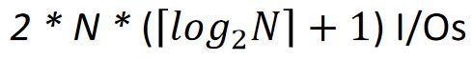
External merge sort: 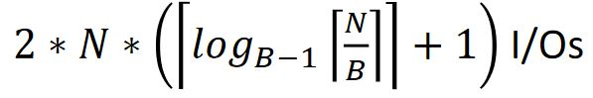
  - Sorting – (projection based on sorting) select only the required columns, sort this => a temporary table, from which we remove adjacent duplicate tuples
    - Cost: M + T (T is O(M)) + sort cost + T
    - Last T only if we remove duplicates
    - Sort cost: see external merge sort / 2way merge, but it’s O( M log M)
    - DUPA NOI E ASA: M + (1/4* M) + SORT COST + (1/4* M) (DACA VREA DISTINCT) ¼ se da in cerinta usually.
  - Hashing
    - Partitioning phase - 1 input page, B - 1 output => hash into B - 1 partitions, no unwanted fields
    - Duplicate elimination phase - one partition at a time; build a new hash table for each to detect duplicates
    - Cost: M + 2 * T (T = no. of partitions)

